- Create a Project for Online Shopping. Add Products to the Cart and the Count should increase as the Products are added to the Cart.
Coding:
<!doctype html>
<html lang="en">
<head>
<meta charset="UTF-8" />
<meta name="viewport" content="width=device-width, initial-scale=1.0" />
<title>ShopMe Store</title>
<style>
body {
display: flex;
flex-direction: column;
align-items: center;
justify-content: center;
background-color: black;
font-family: Arial, Helvetica, sans-serif;
}
ul {
display: flex;

flex-wrap: wrap;
}
li {
border-radius: 20px;
background-color: rgb(255, 255, 255);
display: flex;
flex-wrap: wrap;
flex-direction: column;
align-items: center;
justify-content: center;
transition: transform;
transition-duration: 0.8s;
/* transition-delay: 0.3s; */
}
.product-card {
border-radius: 30px;
transition: transform;
transition-duration: 0.8s;
}
.product-card:hover {
transform: scale(1.1) translateY(-10px);
box-shadow: 0 0 20px rgb(0, 0, 0);
}
#aaa {
margin: 0;
padding: 50px;
width: 60vw;
display: flex;
flex-direction: column;
align-items: center;
justify-content: center;
background-color: rgb(255, 255, 255);
box-shadow: 0 0 100px rgb(255, 255, 255);
}
#bbb {
display: flex;
justify-content: center;
align-items: center;
flex-direction: column;
}

p {
margin-top: 10px;
margin-bottom: 10px;
}
h1 {
margin: 0;
font-size: 50px;
color: rgb(6, 6, 6);
}
h2 {
font-size: 30px;
}
img {
height: 240px;
width: 190px;

margin: 10px;
}
button {
width: 150px;
height: 50px;
background-color: rgb(224, 200, 44);
border-style: none;
border-radius: 30px;
margin-top: 20px;
transition: transform, background-color;
transition-duration: 0.8s;
font-size: 20px;
}
button:hover {
background-color: rgb(74, 248, 0);
transform: scale(1.1) translateY(-10px);
box-shadow: 0 0 10px rgb(0, 0, 0);
}
</style>
</head>

<body>
<div id="aaa">
<div id="bbb">
<h1>ShopMe Store</h1>
<h2>Cart(<span id="cart-count">0</span>)</h2>
</div>

<ul id="itemlist"></ul>
</div>
<script>
let ul = document.getElementById("itemlist");
ul.style.listStyleType = "none";
ul.style.display = "flex";
ul.style.gap = "70px";
ul.style.textAlign = "center";
ul.style.fontSize = "20px";
let moviedetails = [
"Blazers",
"Korean Style shirt(w)",
"Black and gray hoodie",
"Full Sleeve Tshirt",
"Shirt & Pants Set",
"Men's blue jeans",
"Olive green shirt",
"Midi Party Dress",
];

for (let i = 0; i < moviedetails.length; i++) {
let li = document.createElement("li");
let div = document.createElement("div");
let p = document.createElement("p");
let img = document.createElement("img");
let button = document.createElement("button");
div.setAttribute("class", "product-card");
button.setAttribute("class", "btn");
button.addEventListener("click", addcart);
img.src = `assests/image${i}.jpeg`;
div.appendChild(img);

div.appendChild(p).textContent = moviedetails[i];
li.appendChild(div);
li.appendChild(button).textContent = "add cart";
ul.appendChild(li);
}

let cartcount = Number(document.getElementById("cart-count").innerHTML);
function addcart() {
cartcount++;
document.getElementById("cart-count").textContent = cartcount;
}
</script>
</body>
</html>

Output:
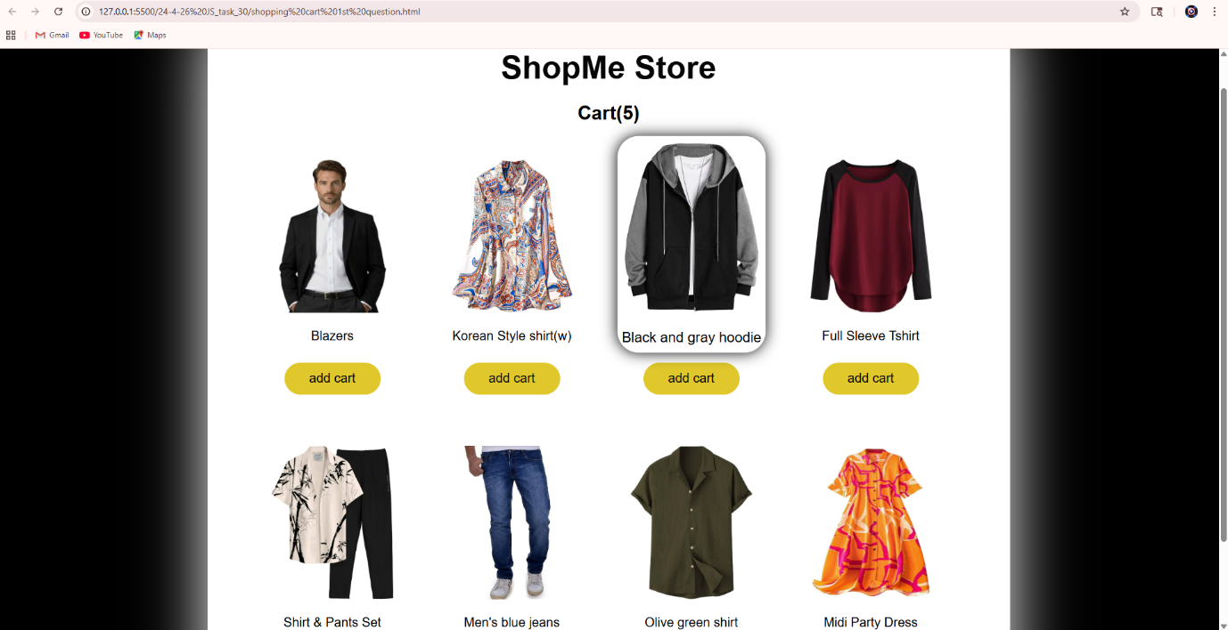

2.Write a function that accepts a callback.
Coding:

function greet(name) {
console.log("Hello " + name);
}

function user(callback) {
let name = "Shanmuga";
callback(name); // calling the callback function
}

user(greet);

Output:
[Running] node "d:\sla assignment\24-4-26 JS_task_30\callback 2nd question.js"
Hello Shanmuga

[Done] exited with code=0 in 0.209 seconds

